**CNH Fast Inquiry:** The CNH Fast Inquiry program is a companion to CNH Connect (CSPS), and allows you to inquire about CNH parts from within NetView programs like Point-of-Sale (POS), Repair Order Maintenance (ROM), Quick Order Adjustments (QOA), and Parts Inquiry (PI) without needing to open CSPS. The inquiry provides the same information about the part as the Part Inquiry contained in CSPS.

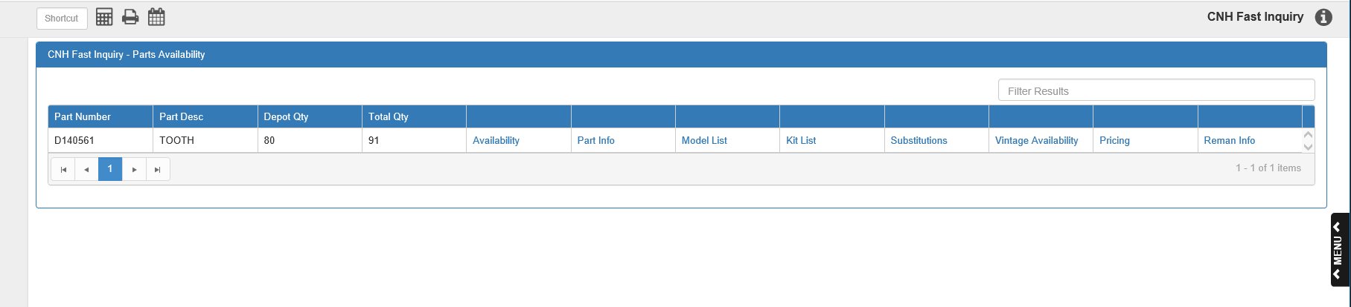

You can make an inquiry for a single CNH part or for all CNH parts listed on a ticket or order (if more than one appears). If you have more than one part on the inquiry, you can sort the entries by clicking the column headers. You can also filter the entries by entering information in the **Filter Results** field.

**Part Number:** This column shows the CNH part number.

**Part Desc:** This column shows the part’s description.

**Depot Qty:** This column shows the quantity of the part currently available at the depot.

**Total Qty:** This column shows the part’s total availability at all CNH warehouses.

**Availability:** Click on “Availability” to view the part’s availability by warehouse.

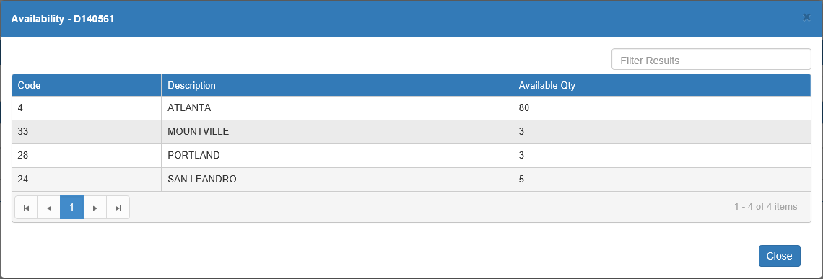

Code: This column lists the CNH warehouse code.

Description: This column lists the warehouse description, which is typically the city where it is located.

Available Qty: This column lists the part’s available quantity at that specific warehouse.

Close: Click this button to close the window and return to the main screen.

**Part Info:** Click “Part Info” to view further details about the part.

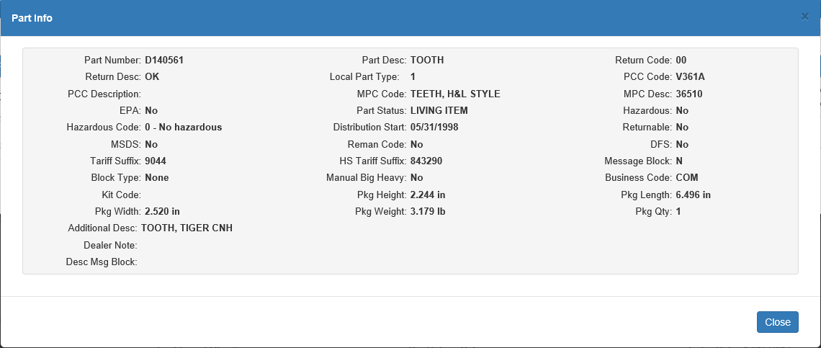

Part Number: This field shows the part number.

Part Desc: This field shows the part description.

Return Code: This field shows the return code.

Return Desc: This field shows the return description.

Local Part Type: This field holds the local part type.

PCC Code: This field holds the purchase category code, or the PCC.

PCC Description: This field holds the PCC description.

MPC Code: This field holds the manufacturing process control, or MPC, code.

MPC Desc: This field holds the MPC description.

EPA: This field indicates whether or not this is an EPA part.

Part Status: This field shows the part’s status.

Hazardous: This field shows whether or not this is a hazardous part.

Hazardous Code: This field shows the part’s hazardous code. If the part is not hazardous, this will say, “0-No hazardous.”

Distribution Start: This field shows the part’s distribution start date, which is the date the manufacturer began distributing it.

Returnable: This field shows if the part is returnable or not (Yes or No).

MSDS: This field shows whether or not the part has a Material Safety Data Sheet, or MSDS.

Reman Code: This field shows the part’s remanufactured code, if this is a remanufactured part.

DFS: This field shows whether or not the part is served directly from the supplier.

Tariff Suffix: This field shows the tariff suffix, if applicable.

HS Tariff Suffix: This field shows the HS tariff suffix, if applicable.

Message Block: This field shows whether or not the part has a message block (Y/N).

Block Type: This field shows the message block type, if the part has one.

Manual Big Heavy: This field shows whether or not this is a “Big Heavy” part.

Business Code: This field shows the part’s business code, if applicable.

Kit Code: This field shows the part’s kit code.

Pkg Height: This field shows the part’s package height.

Pkg Length: This field shows the part’s package length.

Pkg Width: This field shows the part’s package width.

Pkg Weight: This field shows the part’s package weight.

Pkg Qty: This field shows the part’s package quantity, or the amount of the part contained in the manufacturer’s standard package.

Additional Desc.: This field shows an additional part description, if one exists.

Dealer Note: This field shows any dealer notes, if applicable.

Dealer Msg Block: This field shows any error messages currently attached to this part.

Close: Click this button to close the window and return to the main screen.

**Model List:** Click on “Model List” to view a list of all CNH models that the part belongs to.

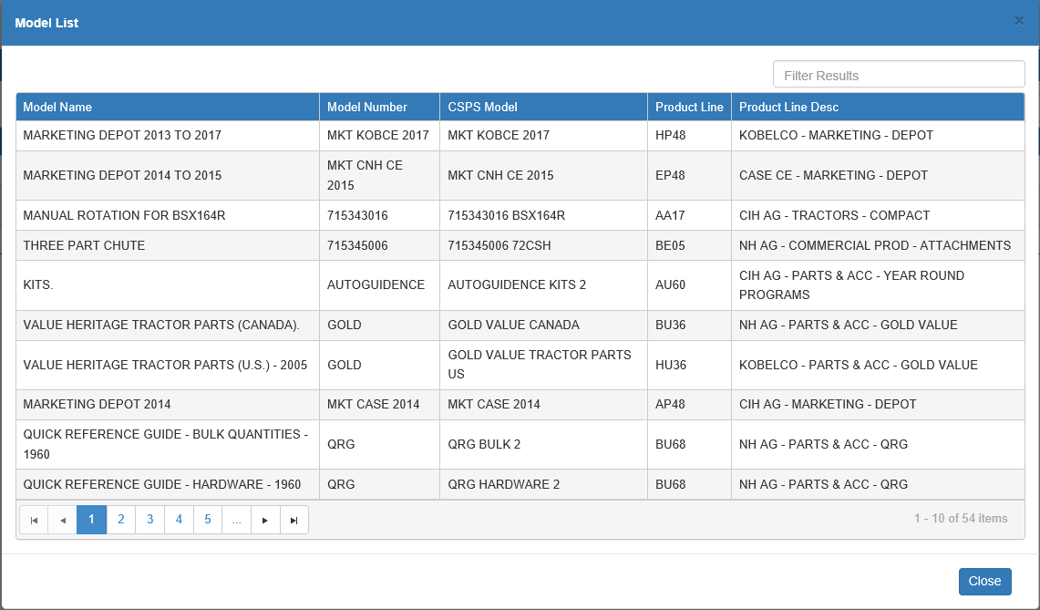

Model Name: This column shows the model name.

Model Number: This column holds the model number.

CSPS Model: This column holds the CSPS model designation.

Product Line: This column shows the model’s product line number.

Product Line Desc: This column shows the description for the model’s product line.

Close: Click this button to close the window.

**Kit List:** Click on “Kit List” to view a list of all CNH kits that the part belongs to.

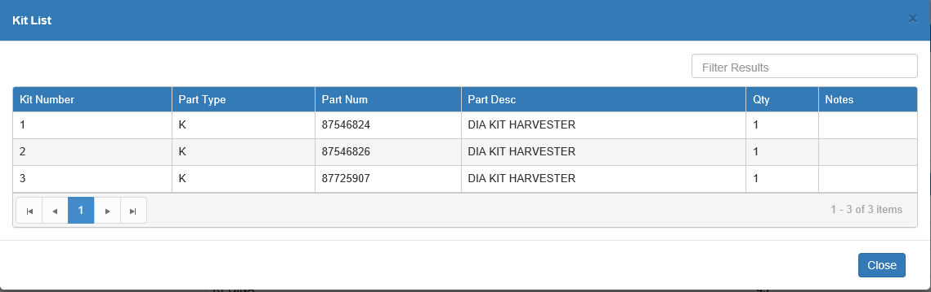

Kit Number: This field shows the kit number.

Part Type: This field shows the part type for the kit.

Part Num: This field shows the part number for the kit.

Part Desc: This field shows the part description for the kit.

Qty: This field shows the quantity of the part contained in the kit.

Notes: This field shows any notes about the kit.

Close: Click this button to close the window.

**Substitutions:** Click on “Substitutions” to view all the part’s substitution chains.

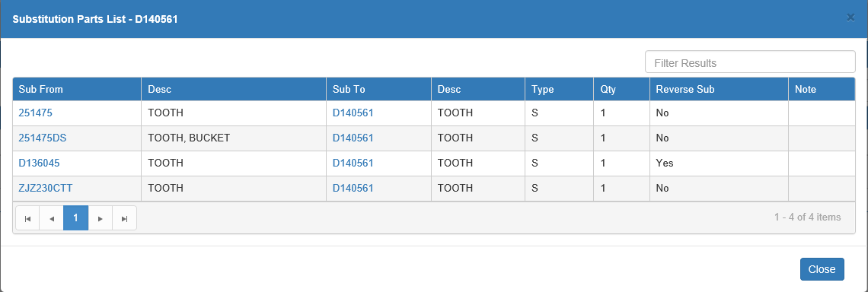

Sub From:This column holds the part number that can be substituted for in the substitution chain. The main inquiry part number will appear here if it has a part that can be substituted for it.

Desc: This column shows the description of the Sub From part.

Sub To: This column holds the part number that can substitute for the Sub From part in the substitution chain. The main inquiry part number will appear here, as in the example above, if it can substitute for another part number.

Desc: This column shows the description of the Sub To part.

Type: This column shows the substitution type.

Qty: This column shows the quantity of substitution parts available.

Reverse Sub:

This column indicates if the substitution chain can work in reverse (if the Sub From part can also substitute for the Sub To part) or not.

Note: This column shows any notes on the substitution chain.

Substitution Availability: Click any part number in the Sub From or Sub To columns to view that part’s current availability:

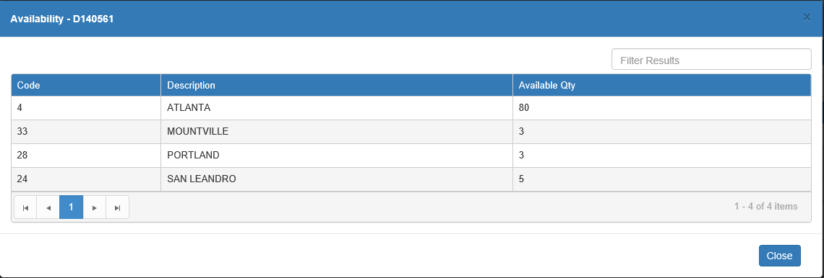

The availability for the main inquiry part shown in this window will match the part’s availability on the main screen.

Close: Click this button to close the window.

**Vintage Availability:** Click on “Vintage Availability” to see availability details for vintage versions of the part:

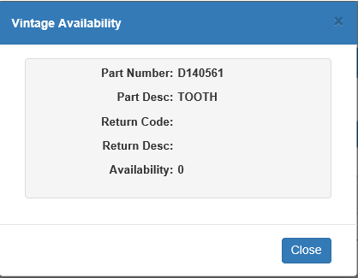

Part Number: This field shows the CNH part number.

Part Description: This field shows the part’s description.

Return Code: This field shows the part’s CNH return code.

Return Description: This field shows the description for the return code.

Availability: This field shows the availability of the vintage part in all CNH facilities. In the case of the example above, there are no vintage versions of the part available.

Close: Click this button to close the window.

**Pricing:** Click on “Pricing” to view the part’s pricing by order type:

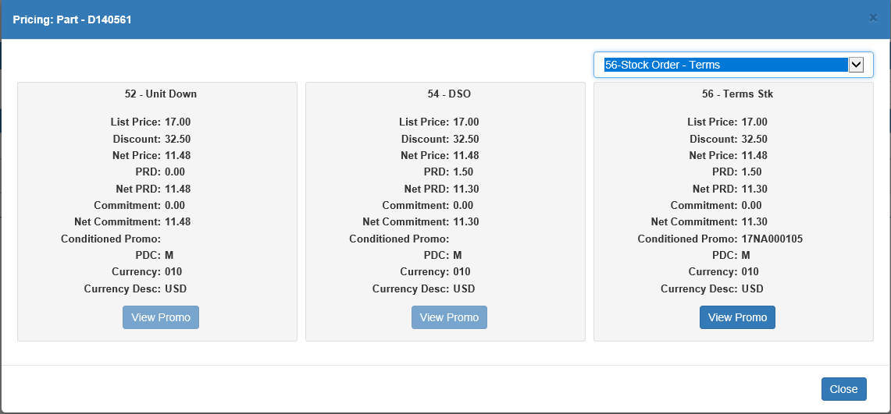

The window can only show the pricing for three order types at once.  Order types 52-Unit Down and 54-DSO will always show by default, but you may select any type desired as the third type.

Select Order Type: Use this drop-down menu to select the third order type you want to view.  However, if you have set an order type other than Unit Down or DSO as your default type for orders, the pricing for that order type will display as the third type by default (though you can still use the menu to pick another one).

Pricing Set Fields: All three pricing sets will show the following information:

**List Price:** This shows the part’s list price.

**Discount:** This shows the part’s discount percentage, if applicable.

**Net Price:** This shows the part’s net price (list price minus calculated discount amount).

**PRD:** This shows the part’s performance raw discount, or PRD, percentage.

**Net PRD:** This shows the part’s net price after the calculated PRD amount is subtracted.

**Commitment:** This shows the part’s commitment discount percentage.

**Net Commitment:** This shows the part’s net price after both the calculated PRD and calculated commitment have been subtracted.

**Conditioned Promo:** This field shows the part’s conditioned promo code, if applicable.

**PDC:** This field shows the part’s discount code.

**Currency:** This field shows the dealer currency code.

**Currency Desc:** This field shows the description of the currency code, generally indicating what the currency type is (dollars, pounds, euros etc.).

View Promo: If the order type has a promotion for the part, this button in the type’s section of the screen will be active. Click on it to view the promotional details in a new window:

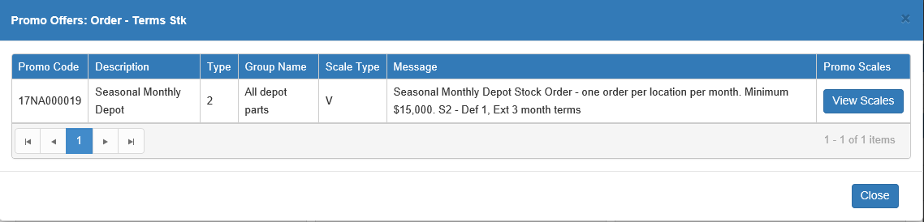

**Promo Code:** This column shows the promo code.

**Description:** This column shows the promo’s description.

**Type:** This column shows the promo’s type

**Group Name:** This column shows the promo’s group name.

**Scale Type:** This column shows the promo’s scale type.

**Message:** This column holds the message explaining the promo details.

**Promo Scales/View Scales:** If available, this column holds the **View Scales** button, which opens the promo scale details in a new window:

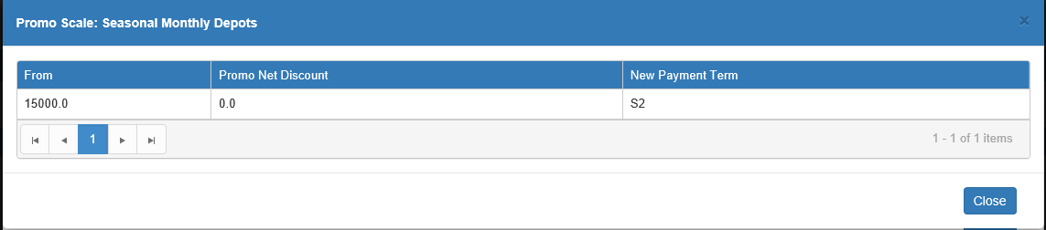

* **From:** This column shows the minimum quantity or amount required for the order to be eligible for the promo.
* **Promo Net Discount:** This column shows the promo benefit, either the discount percentage or the promo price.
* **New Payment Term:** This column shows the eligible promo payment term code, if applicable.

**Reman Info:** If the part is a remanufactured part, click on “Reman Info” to view a list of all parts associated with this part’s status as a remanufactured part:

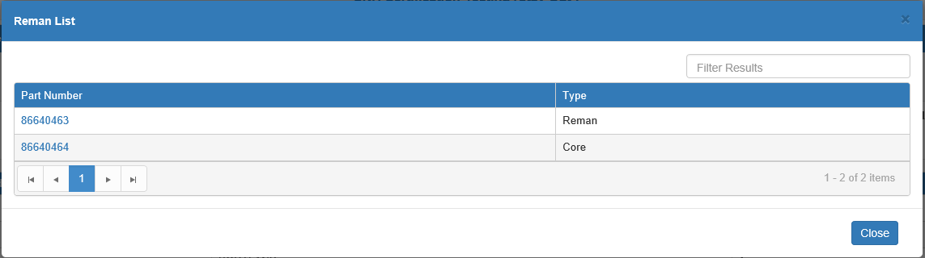

Part Number:This column shows the part number related to the remanufacture. Click it to view the part’s availability. The main inquiry part number’s availability will match its availability displayed on the main screen.

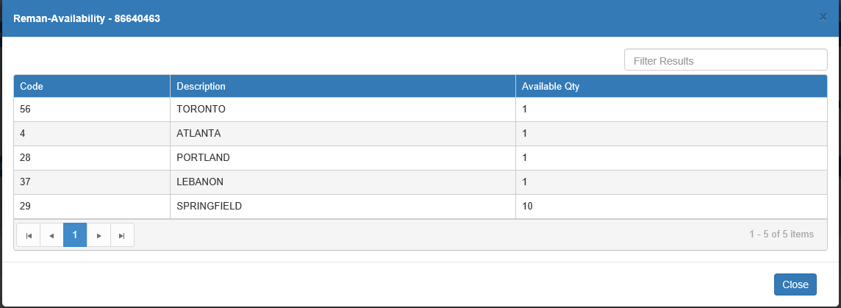

Type: This column shows the part’s type (New, Reman, Core, etc.), which explains its relation to the remanufactured part. For example, if the type is Core, that means the part is likely a core that was reused in the remanufactured part.

Close: Click this button to close the window.

**Accessing Fast Inquiry:** To access the CNH Fast Inquiry, you need two things:

* A CNH part number
* An active **Fast Inquiry** button

Below are instructions for how to implement both in NetView programs that have Fast Inquiry access.

Fast Inquiry in Point-of-Sale (POS): Once you add a CNH part to a ticket in POS, the **Fast Inquiry** button will activate, as shown below:

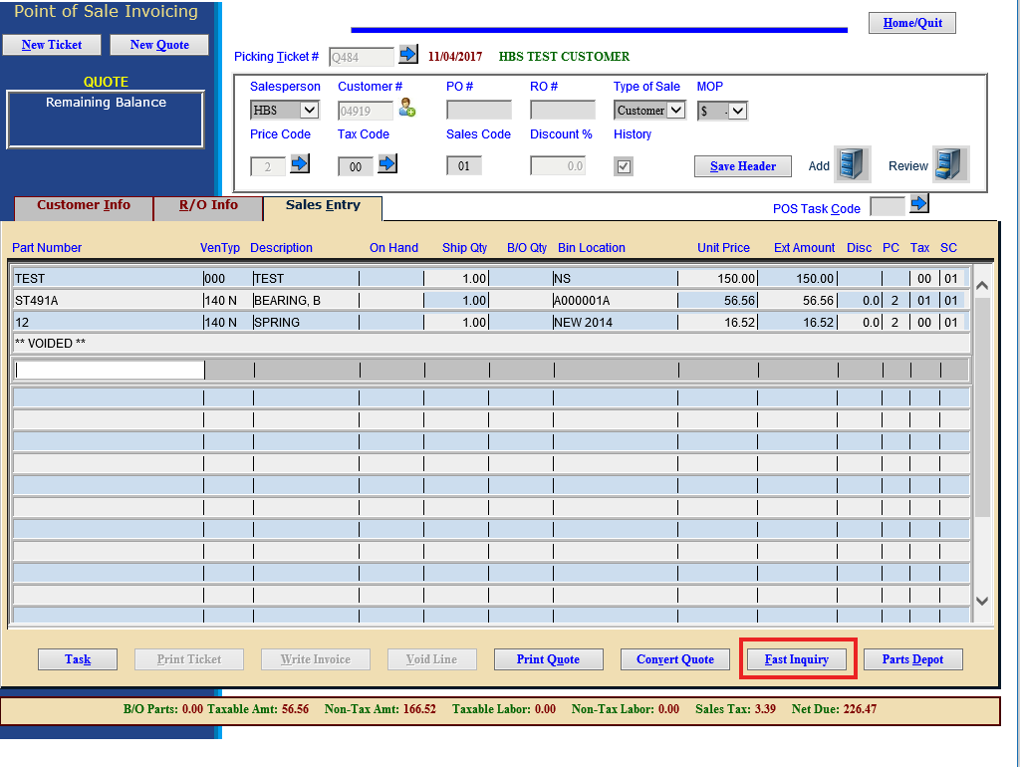

Save the ticket and come back to it. Once you do, you will be able to click the button and perform an inquiry for **all** CNH parts on the ticket. To make a Fast Inquiry for a single CNH part, highlight that part’s line on the ticket before clicking the button.

Fast Inquiry in Quick Order Adjustments (QOA): Once you add a CNH part to an order in QOA, the **Fast Inquiry** button will activate, as shown below:

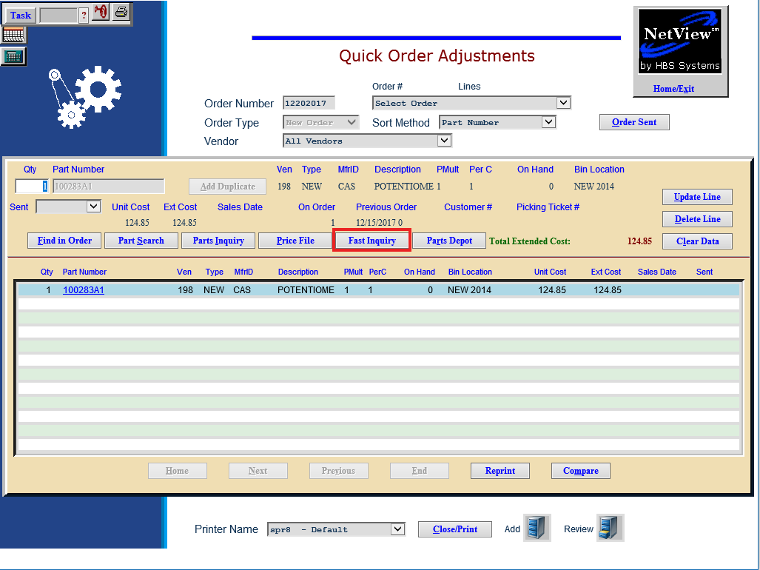

Save the ticket and come back to it. Once you do, you will be able to look up that part’s information by selecting its line on the order (as shown in the image above) and clicking the button.

Fast Inquiry in Repair Order Maintenance (ROM): Once you’ve added a condition to a repair order in ROM and are ready to add parts, click the **Parts** button. The following window will open containing the Fast Inquiry button:

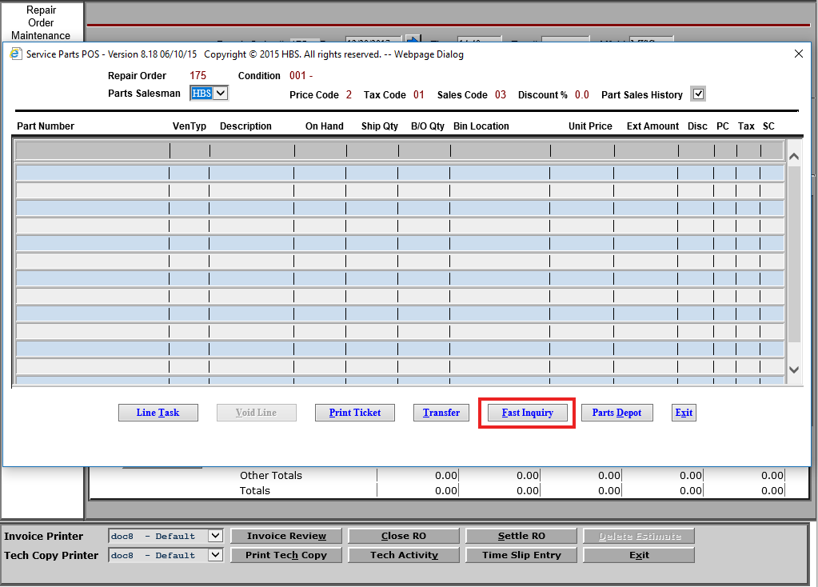

Add a CNH part to the order, then exit and return the Parts screen. Once you do, you will be able to click the button and perform an inquiry for **all** CNH parts on the order. To make a Fast Inquiry for a single CNH part, highlight that part’s line on the order before clicking the button.

Fast Inquiry in Parts Inquiry (PI): When you look up a CNH part in the NetView Parts Inquiry program, you can click the **Fast Inquiry** button at the bottom of the screen to open the CNH Fast Inquiry for that particular part.

